A

PROJECT REPORT ON

FRUATABLES ONLINE SHOPPING WEBSITE

SUBMITED TO



SEVENMENTOR AND TRAINING PVT LTD.

IN THE PARTIAL FULLFILMENT OF THE

DEPARTMENT OF DEVELOPMENT

Sarika Kore

SUBMITED BY

 Rajesh Ananta Patil

Prof.Sarika Kore

2023-24



**“**A Step Ahead In Education**”**

SEVENMENTOR AND TRAINING PVT LTD.

21 & 25/A Wing, Shreenath Plaza, 1st floor, Dnyaneshwar Paduka Chowk, Shivaji Nagar,Pune

CERTIFICATE

DEPARTMENT OF DEVELOPMENT

This is to certify **MR.Rajesh Ananta Patil** has satisfactorily carried out the required project work according to the the syllabus of SevenMentor pvt ltd. during the academic year 2023-2024.This project represents the benefited work.

PROJECT GUIDE HEAD OF DEPT.

INTERNAL EXAMINER EXTERNAL EXAMINER

Date:

ACKNOWLEDGEMENT

It is distinct honor and proud privilege to acknowledge with our attitude , the keen interest taken by **“Prof .Sarika Kore”** and inspiring suggestions and constant supervision and encouragement who had made it possible of pursue and complete this project of – **“Fruitables online shopping website”** effectively.

We would take this opportunity to express our profound series in definers to all the member of staff of their constant help.

It has given us Immense Pleasure to associate ourselves with through provoking and absorbing .We are grateful to those who have directly and indirectly co-operated to finish this project work.

We greatly appreciate our staff members for their keen interest and numbers of fruitful suggestion at various stages during the completion of this endeavours, which help to reach the depth of this work.

We would also like to thank to our friends who always had helping hand whenever needed and also for their co-operation moral support for doing this project.

By, Date:

**Rajesh Ananta Patil**

## INDEX

|  |  |
| --- | --- |
| SR.NO | TITLE |
| 1 | Abstract |
| 2 | Introduction to the System 1-Introduction  2-Problem Statement 3-Proposed System  4-Objective and Purpose 5-Existing System  6-Scope of the System 7-Need of the System |
| 3 | System Analysis 1-Feasibility Study   1. Fact Finding Technique 2. Hardware and Software Requirement |
| 4 | System Design 1-E-R Diagram **2**-UML Diagram   1. Use Case Diagram 2. Activity Diagram 3. Component Diagram 4. Class Diagram 3-Data Dictionary |
| 5 | I/O Screens |
| 6 | Advantages and Disadvantages |
| 7 | Features |
| 8 | Future Enhancement |
| 9 | Conclusion |

**ABSTRACT**

Our Project is to develop the technique for fingerprint authentication in ATM. This target can be mainly decomposed into image prepossessing, feature extraction and feature match. For each sub-task, some classical and up-to-date methods in literature are analyzed. Based on the analysis, an integrated solution for fingerprint recognition and authentication is developed for demonstration. Our demonstration program is coded in ASP.NET & MATLAB. For the program, some optimization at coding level and algorithm level are proposed to improve the performance of my fingerprint authentication system. These performance enhancements are shown by experiments conducted upon a variety of fingerprint images. Also, the experiments illustrate the key issues of fingerprint recognition that are consistent with what the available literatures say.

# INTRODUCTION TO THE SYSTEM:

* **INTRODUCTION:**

Welcome to Fruitables, your premier online destination for fresh fruits and vegetables! Our website, crafted with the latest technologies including Bootstrap 5, HTML5, CSS3, JavaScript, and jQuery, offers you a seamless shopping experience right from the comfort of your home. Dive into a world of vibrant colors and tantalizing flavors as you explore our extensive selection of farm-fresh produce. Whether you're craving succulent strawberries, crisp lettuce, or exotic mangoes, we've got you covered. With user-friendly navigation and visually appealing design, Fruitables makes it easy for you to find exactly what you need and place your order with just a few clicks. Say goodbye to long supermarket queues and hello to convenient online shopping with Fruitables. Let's embark on a journey to healthier, happier living, one delicious fruit and veggie at a time.

### PROBLEM STATEMENT:

Despite the proliferation of online shopping platforms, many consumers still face challenges when it comes to purchasing fresh fruits and vegetables online. While there are numerous websites offering a variety of products, the lack of user-friendly interfaces and visually appealing designs often leads to frustration and dissatisfaction among users. Additionally, issues such as limited product selection, unclear product descriptions, and cumbersome checkout processes further hinder the online shopping experience for those seeking high-quality produce.

Recognizing these challenges, Fruitables aims to address the following key issues

1. User Experience

2. Product Selection

3. Information Clarity

4.Checkout process

### THE PROPOSED SYSTEM:

Fruitables aims to create a seamless and enjoyable online shopping experience for customers seeking high-quality fruits and vegetables. Leveraging modern web development technologies such as Bootstrap 5, HTML5, CSS3, JavaScript, and jQuery, the proposed system will offer an intuitive user interface, an extensive product selection, clear product information, and a streamlined checkout process.

### OBJECTIVE AND PURPOSE:

Objective:

The primary objective of Fruitables, an online fruits and vegetables shopping website developed using Bootstrap 5, HTML5, CSS3, JavaScript, and jQuery, is to provide customers with a seamless and enjoyable platform for purchasing high-quality produce from the comfort of their homes. By leveraging modern web development technologies and design principles, Fruitables aims to revolutionize the online shopping experience for fruits and vegetables, offering a user-friendly interface, extensive product selection, clear product information, streamlined checkout processes, and responsive customer support.

Purpose:

The purpose of Fruitables is to address the existing challenges and limitations faced by consumers when shopping for fresh fruits and vegetables online. By creating an intuitive and visually appealing website, Fruitables seeks to enhance user satisfaction and engagement, making it easier for customers to find, purchase, and enjoy top-quality produce. Additionally, Fruitables aims to promote healthy eating habits and support sustainable agriculture by sourcing products from reputable growers and suppliers. Ultimately, Fruitables strives to become the go-to destination for customers seeking convenient, reliable, and delicious fruits and vegetables delivered straight to their doorstep.

­

### THE EXISTING SYSTEM:

The existing system for online fruit and vegetable shopping typically involves a variety of websites and platforms that offer similar services to Fruitables. However, these systems often suffer from several shortcomings, which create challenges for both customers and businesses. the existing system for online fruit and vegetable shopping presents numerous challenges that hinder the user experience and limit business growth opportunities. Fruitables aims to address these shortcomings by providing a comprehensive and user-centric platform that leverages modern web development technologies to deliver a superior shopping experience for customers.

### SCOPE OF THE SYSTEM:

The scope of the Fruitables online fruits and vegetables shopping website includes:

* User-friendly interface design using Bootstrap 5, HTML5, CSS3, JavaScript, and jQuery.
* Product management with inventory control and organization into categories.
* Streamlined shopping cart and checkout process with secure payment options.
* User account management for personalized experiences and order tracking.
* Search and filtering functionality for easy product discovery.
* Customer support channels and feedback mechanisms.
* Performance optimization and scalability measures.
* Implementation of robust security measures to protect user data and ensure compliance.

### NEED OF THE SYSTEM:

The need for the Fruitables online fruits and vegetables shopping website arises from the growing demand for convenient and accessible platforms for purchasing fresh produce. With the increasing reliance on online shopping, especially in the wake of global events, consumers seek efficient ways to procure high-quality fruits and vegetables from the comfort of their homes. Fruitables addresses this need by providing a user-friendly and visually appealing platform built on modern web technologies like Bootstrap 5, HTML5, CSS3, JavaScript, and jQuery. This system offers customers a seamless shopping experience with easy navigation, extensive product selection, clear information presentation, secure payment options, and responsive customer support, fulfilling the demand for an efficient and reliable online marketplace for fresh produce.

# SYSTEM ANALYSIS:

### FEASIBLITY STUDY:

1. ECONOMIC FEASIBILTY:

The economic feasibility of Fruitables, the online fruits and vegetables shopping website, is evident in its potential to generate revenue through increased sales and cost efficiencies. The platform minimizes development costs while maximizing user engagement and conversion rates. Furthermore, the scalability of the system allows for efficient growth and expansion, ensuring long-term profitability. With the rising demand for convenient online shopping solutions, Fruitables presents a lucrative opportunity to tap into the market for fresh produce, driving economic success and sustainability.

2.TECHNICAL FEASIBILTY:

The economic feasibility of Fruitables, the online fruits and vegetables shopping website, is evident in its potential to generate revenue through increased sales and cost efficiencies. By leveraging modern web development technologies like Bootstrap 5, HTML5, CSS3, JavaScript, and jQuery, the platform minimizes development costs while maximizing user engagement and conversion rates. Furthermore, the scalability of the system allows for efficient growth and expansion, ensuring long-term profitability. With the rising demand for convenient online shopping solutions, Fruitables presents a lucrative opportunity to tap into the market for fresh produce, driving economic success and sustainability.

3.OPERATIONAL FEASIBILTY:

Fruitables, is an online fruits and vegetables shopping website developed using Bootstrap 5, HTML5, CSS3, JavaScript, and jQuery, demonstrates strong operational feasibility. The platform streamlines the entire shopping process, from browsing to checkout, ensuring ease of use for both customers and administrators. With intuitive navigation, comprehensive product management, and efficient order processing capabilities, Fruitables minimizes operational complexities and maximizes productivity. Additionally, its scalable infrastructure allows for seamless adaptation to changing demands and growth opportunities, ensuring sustained operational success in the dynamic e-commerce landscape.

### FACT FINDING TECHNIQUES:

The fact-finding techniques are a process of collection of data and information based on techniques that contain observation, record review, questionnaires and interview. Study the current system requirement investigation depends upon fact-finding techniques. Information gathering is very important while developing any system of following method have been adopt while fact gathering techniques.

### There are 4 parts in fact-finding techniques:

1. OBSERVATION:

Observation is very important part of fact-finding

technique from other techniques. This technique is used in our system to observing the whole by observing how the system work. How many different techniques are there in the system? What are the way to maintain the system we observed flow of document and we have got lots of information which help us lots of implements in the system and it also help in finding alternative rules and regulation and procedure, Also helps in making proper use of document.

1. RECORD REVIEW:

The technique proves in fact-finding of system

and points must be covered while designing the current system observing documents register and data which are prepared manually by the department carries out the techniques of record review. It helps the design of input output required for the system, the database, screen designing, etc. Thus, the technique proves very helpful for analyzing about the system.

1. QUESTIONNAIRES:

Questionnaires are used to get more information from user. We have able to collect good and convenient data regarding our project.

In questionnaires system is paper out system in which we ask the question in paper formatted as like:-

* 1. How to design online system? 2.How your system workout?

1. How you solve problem of customer? etc.,
2. INTERVIEW:

Interview is fact-finding technique where we get

information by face-to-face interaction. In these we can ask questions like:-

* 1. How to work in this system?
  2. How the system work in your center? etc.,

### HARDWARE AND SOFTWARE REQUIREMENT:

1.HARDWARE REQUIREMENT:

-Processor: i3

-Hard Disk: 5GB

-Memory: Atleast 512MB RAM

2.SOFTWARE REQUIREMENT:

-Operating Systems: Windows7 and above

-Front end: HTML, CSS, BOOTSTRAP, JQUERY and JAVASCRIPT

In the box:

* HTML & CSS
* Library & PLugins
* JavaScript Source Files
* Demo Images

# SYSTEM DESIGN:

### E-R DIAGRAM:

• 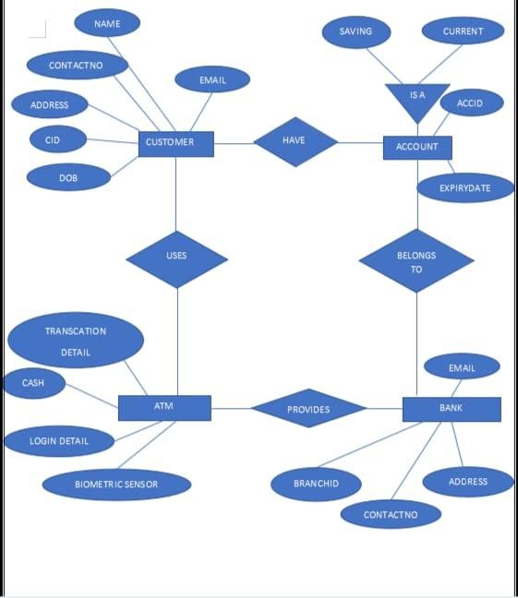

1. An entity relationship diagram (ERD), also known as entity relationship model, is a graphical representation that depicts relationship among people, objects, places, concept or events within an information technology (IT) system.
2. An ERD uses data modelling techniques that can help define business processes and serve as a foundation for a relational database.

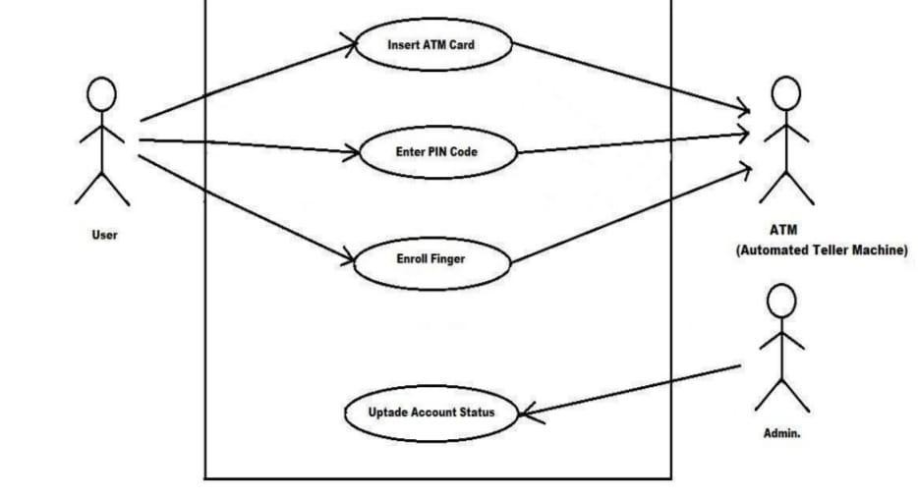

### USE-CASE DIAGRAM:

1.A use case diagram describe a high-level function and scope of a system.

1. These diagrams also identify the interactions between the system and its actor.
2. The use cases and actors in use case diagram describes what the system does and how the actors use it, but not how the system works.
3. Symbols and their functionality:
   1. Use Case

b.

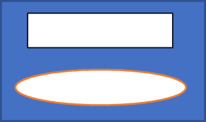

SYSTEM

System

c. Relationships

### ACTIVITY DIAGRAM:

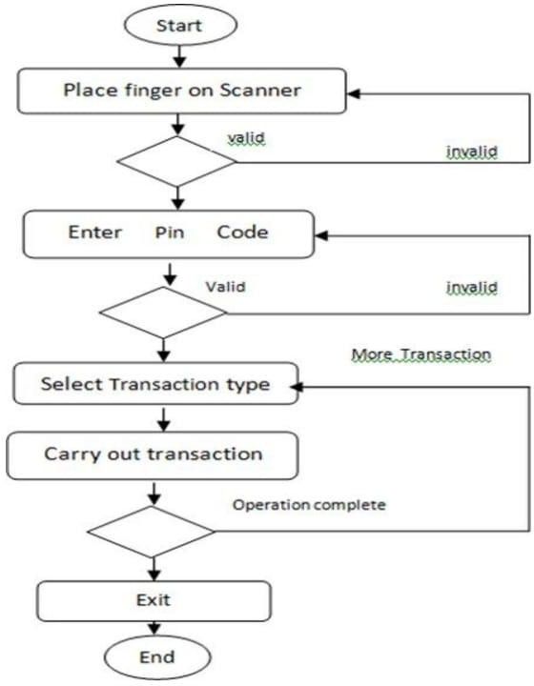

1. Activity diagram is basically a flowchart to represent the flow from one activity to another activity.
2. It is use to demonstrate the logic of algorithm. 3.It describes the steps performed in UML case.

4.It is used to simplify and improve any process by clarifying complicated use cases.

### COMPONENT DIAGRAM:

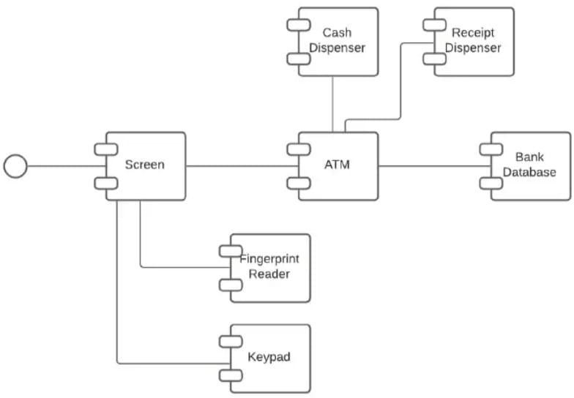

1.A component diagram displays the structural relationship of a software system.

2.Components communicate with each other using interfaces. 3.The interfaces are linked using connectors.

### CLASS DIAGRAM:

1.A class diagram models the static view of a system.

1. It comprises the classes, interfaces and collaborations of a system; and the relationships between them.
2. Here, in the class diagram we are showing the different classes consisting of different components of our system.

### DATA DICTIONARY:

# INPUT OUTPUT SCREENS:

Home Page:

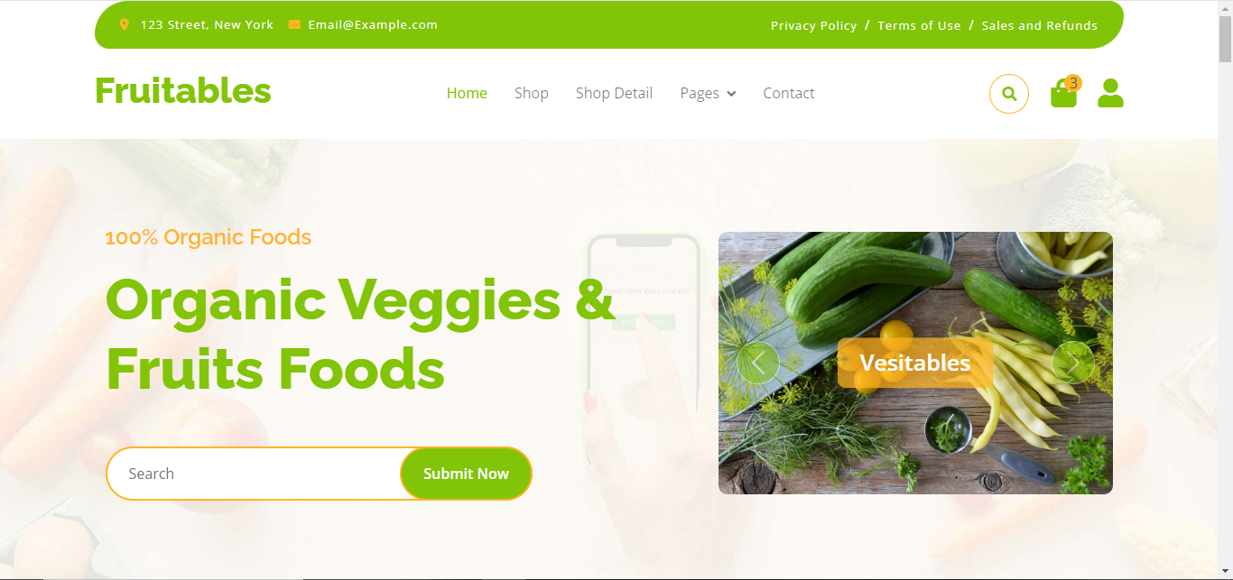

Shop page:

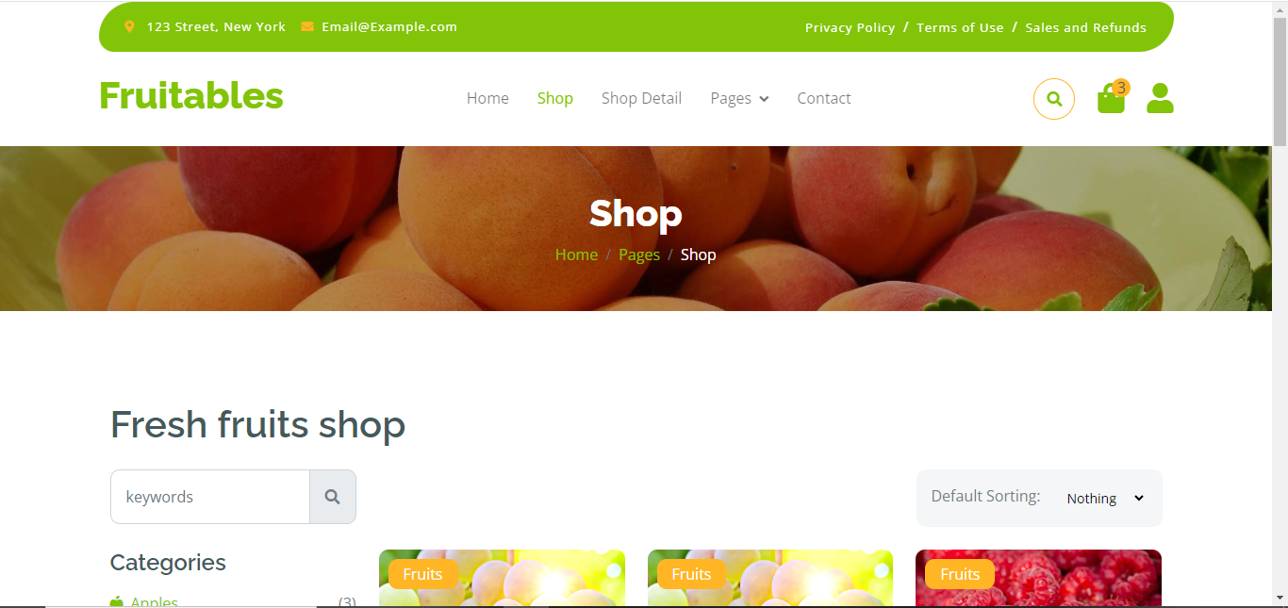

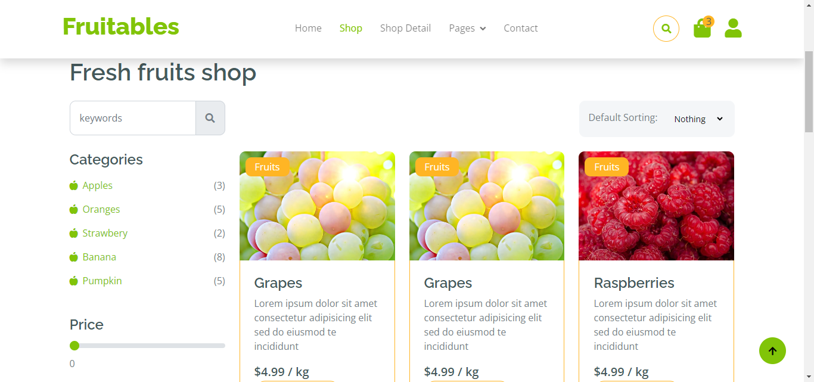

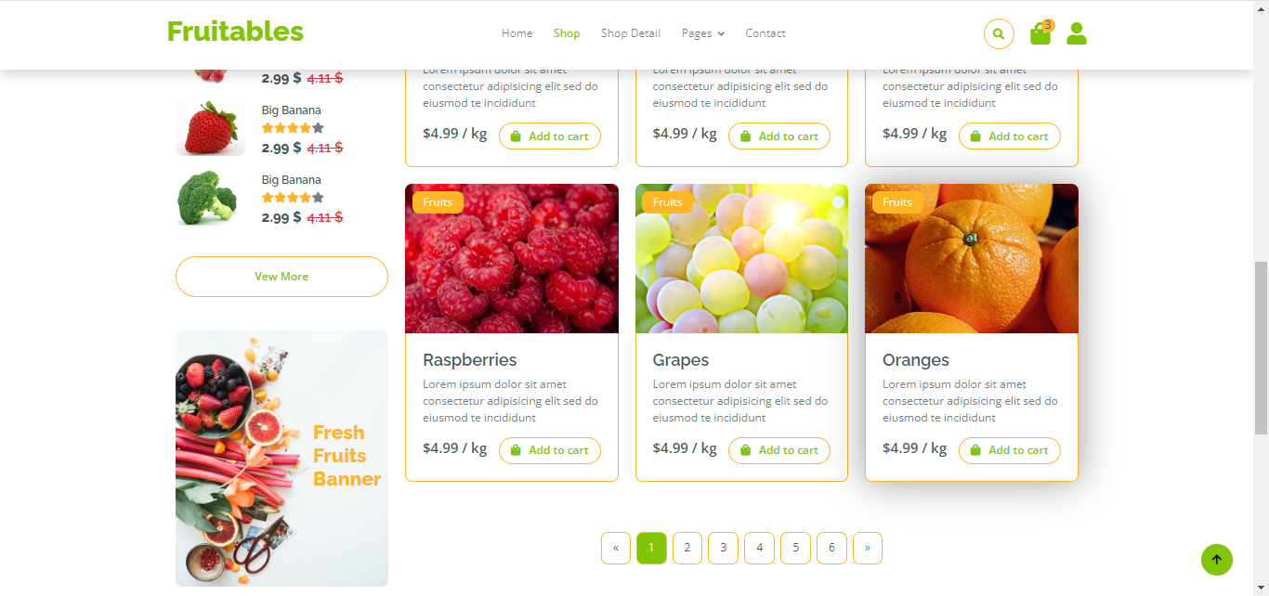

Shop details:

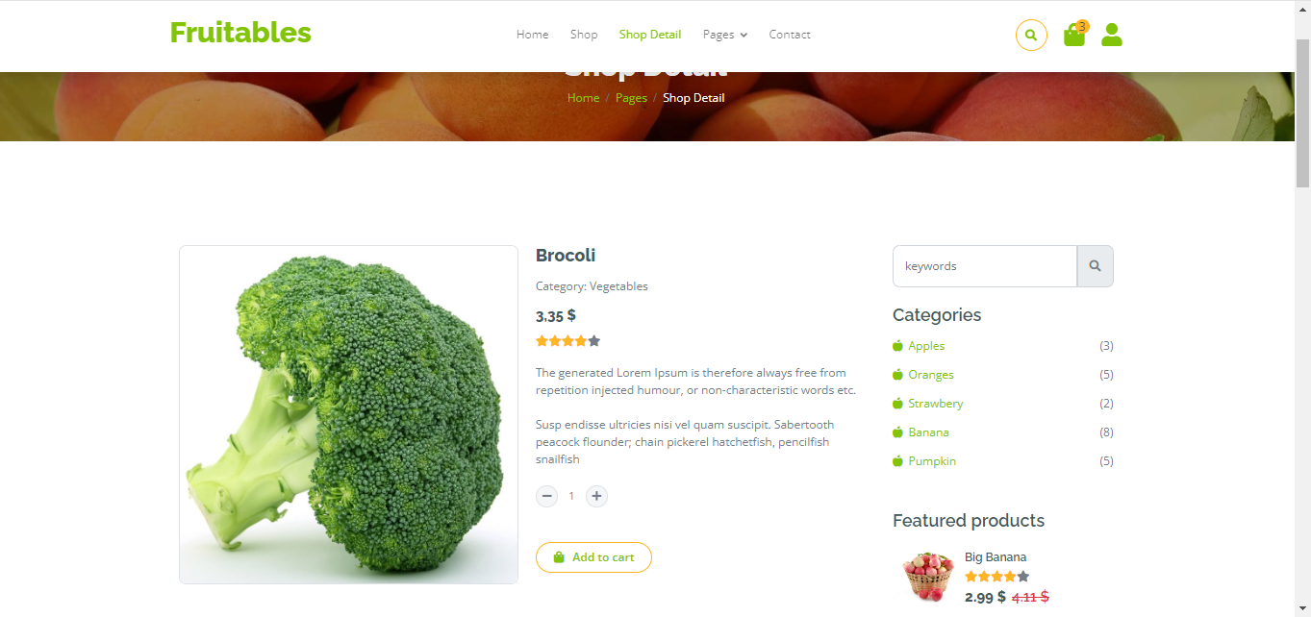

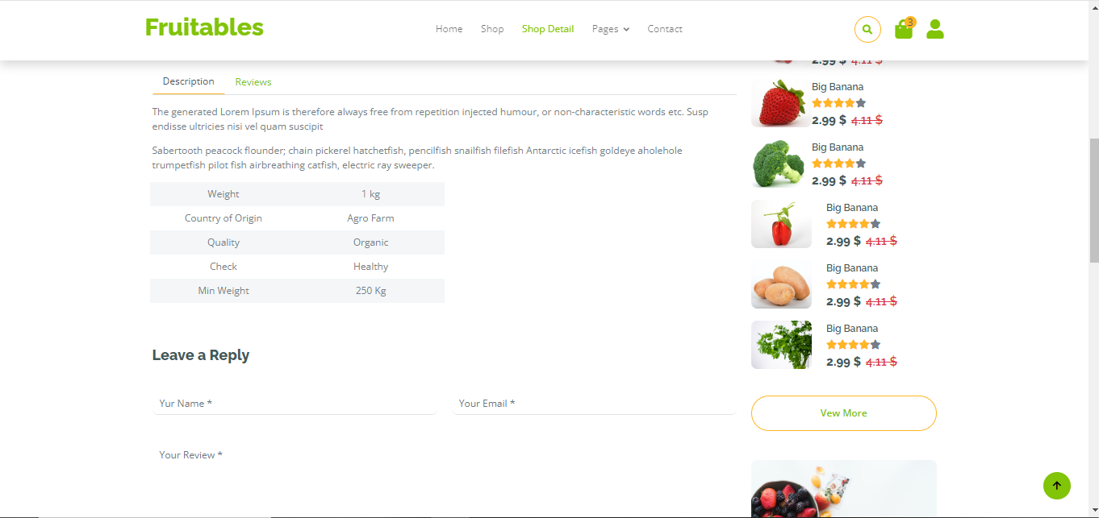

Cart:

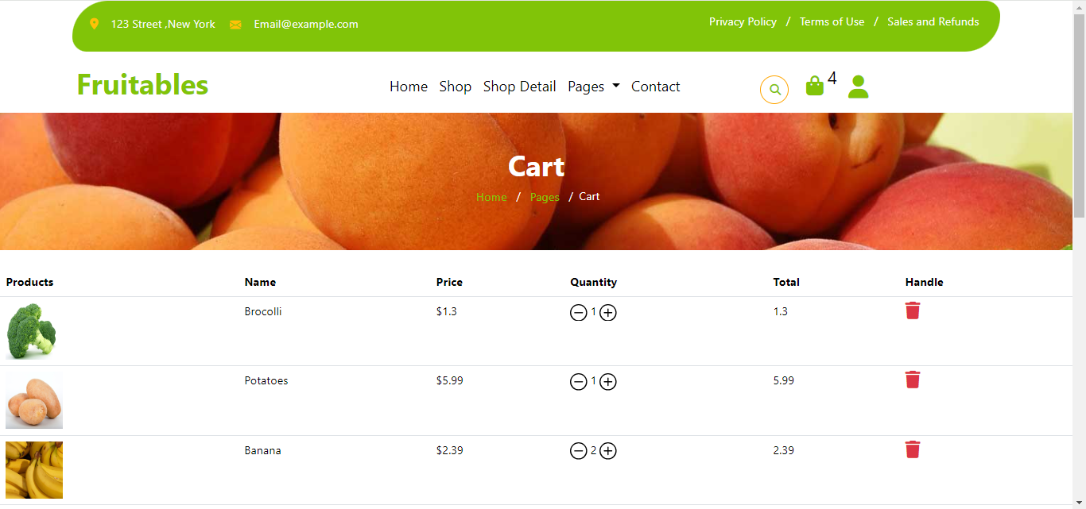

Checkout:

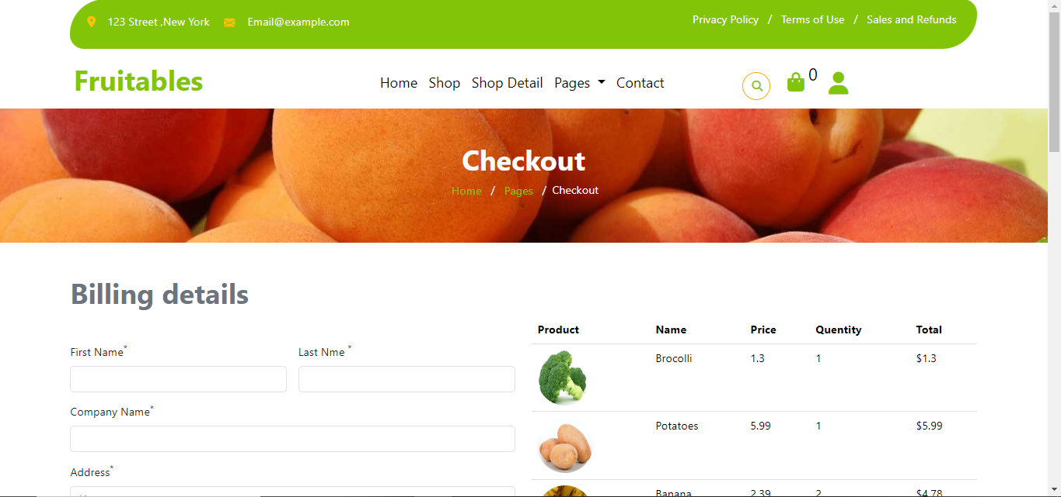

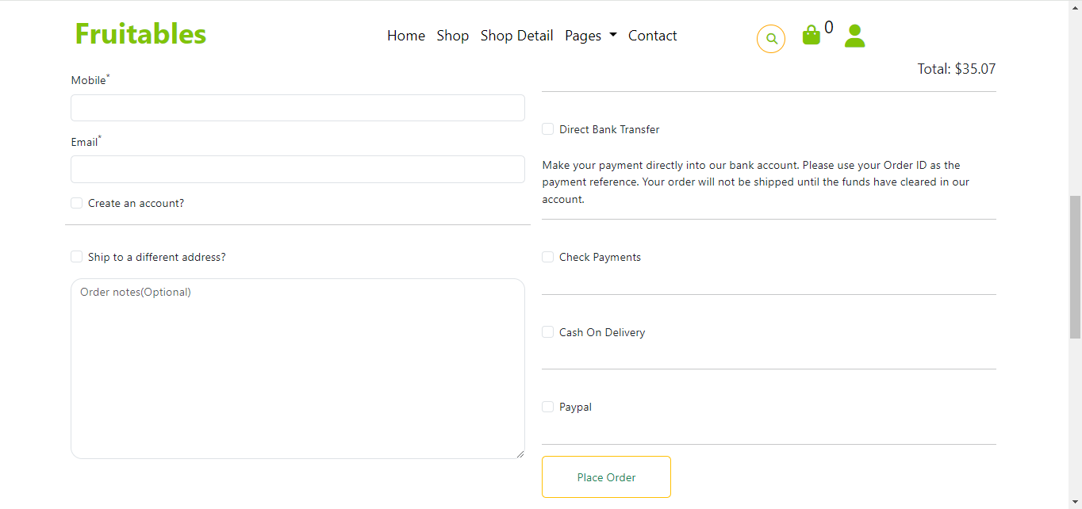

Testimonial:



Page not found:

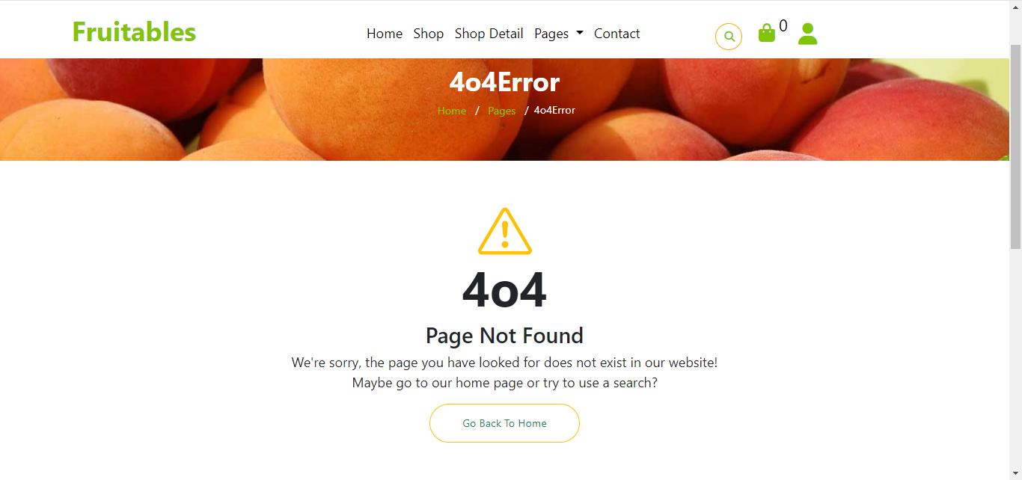

Contact:

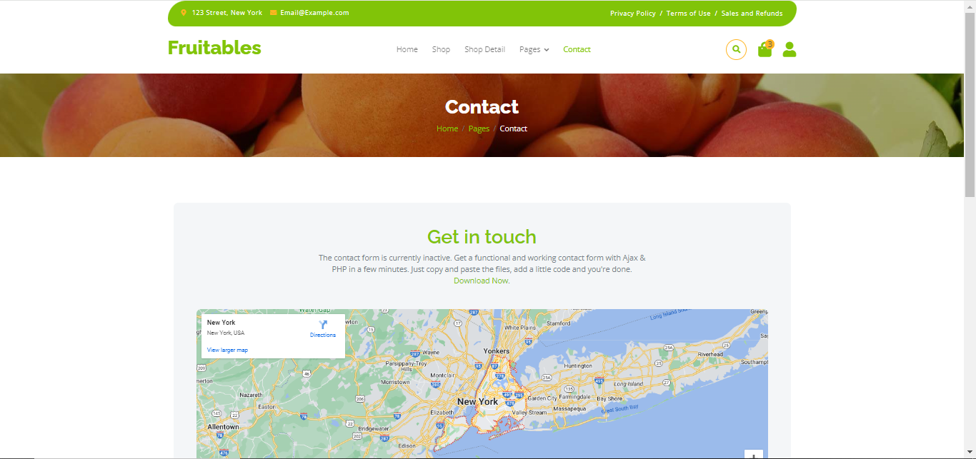

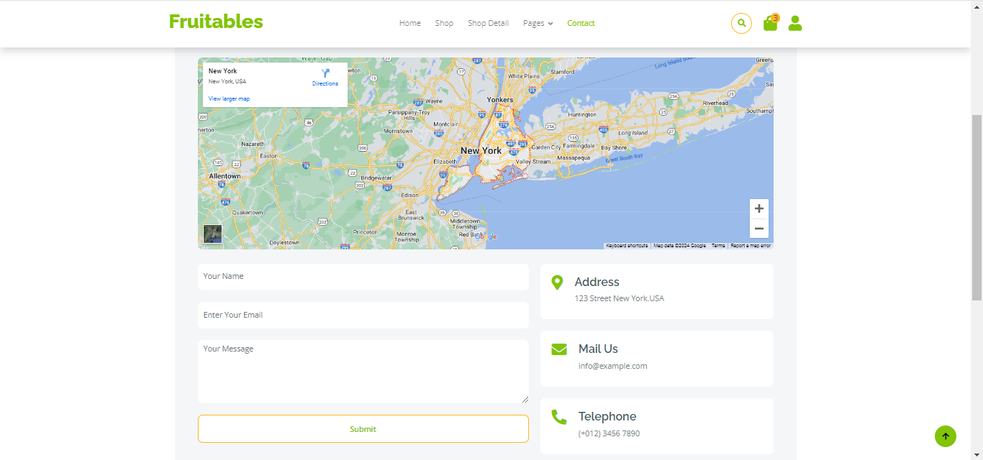

Bestseller products:

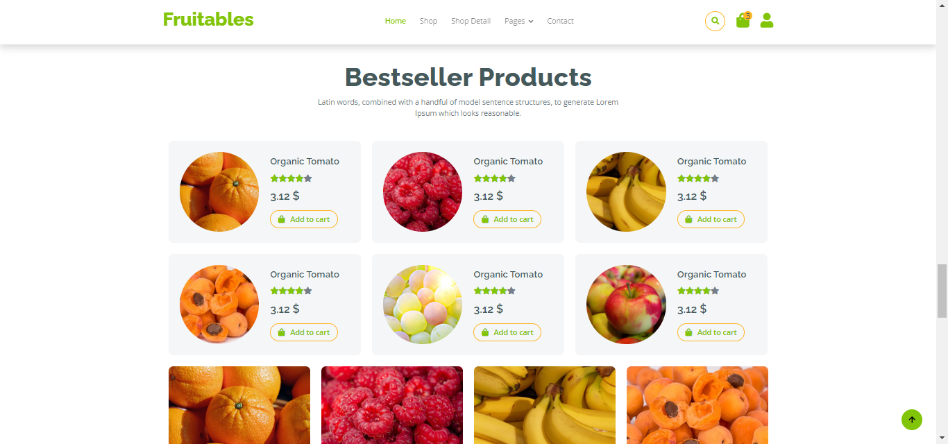

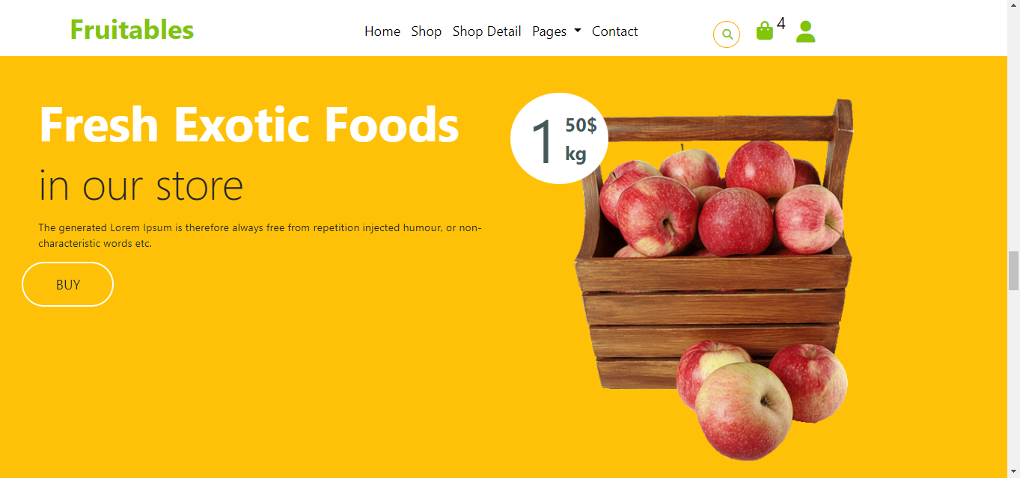

Footer:

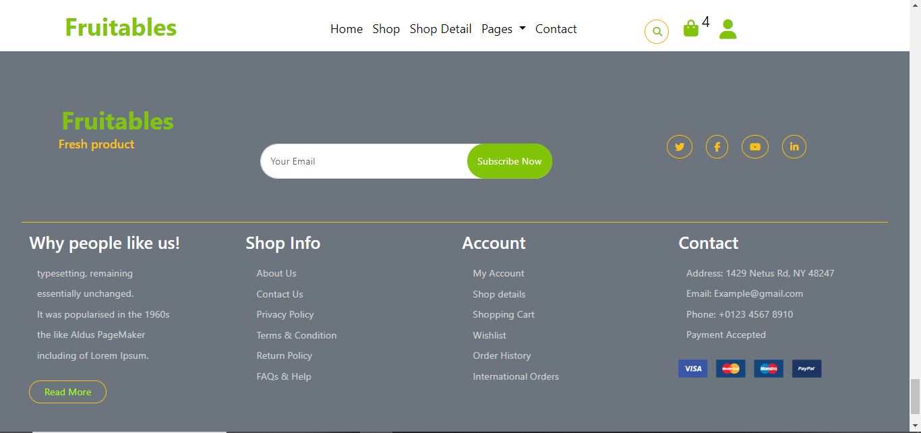

## ADVANTAGES AND DISADVANTAGES

### ADVANTAGES:

1. Enhanced User Experience: Fruitables offers a visually appealing and user-friendly interface, optimized for various devices, ensuring a seamless shopping experience for customers.

2. Efficient Development: Leveraging Bootstrap 5, HTML5, CSS3, JavaScript, and jQuery streamlines development, reducing time and resources required for website creation and maintenance.

3. Responsive Design: The website adapts to different screen sizes and resolutions, catering to the preferences of mobile, tablet, and desktop users, thereby expanding the potential customer base.

4. Improved Interactivity: JavaScript and jQuery enhance website interactivity, enabling dynamic features like product sliders, interactive menus, and real-time updates, enhancing user engagement.

5. Faster Loading Times: HTML5 and CSS3 optimize website performance, resulting in faster loading times and smoother navigation, which reduces bounce rates and increases customer retention.

6. Cross-Browser Compatibility: Compatibility across multiple web browsers ensures consistent user experiences, eliminating compatibility issues and maximizing accessibility for all users.

7. Modern Aesthetics: Bootstrap 5's modern design elements and customizable components allow for the creation of visually appealing layouts, enhancing the brand image and attracting potential customers.

8. Scalability: The modular structure of Bootstrap 5 and the flexibility of HTML5, CSS3, JavaScript, and jQuery facilitate scalability, enabling seamless expansion to accommodate growing product catalogs and user bases.

* **DISADVANTAGES:**

1. Limited Customization: While Bootstrap 5 provides a robust set of pre-designed components, there may be limitations in customization options, potentially leading to a generic look and feel for the website.
2. Code Overhead: Including libraries like Bootstrap 5, jQuery, and other JavaScript frameworks can result in increased code overhead, potentially affecting website performance, particularly on slower devices or internet connections.
3. Learning Curve: Mastery of Bootstrap 5, HTML5, CSS3, JavaScript, and jQuery may require time and effort, leading to longer development cycles and potential delays in project delivery.

### APPLICATION:

Fruitables, the online fruits and vegetables shopping website developed using Bootstrap 5, HTML5, CSS3, JavaScript, and jQuery, serves as a convenient and efficient platform for customers to browse, select, and purchase fresh produce from the comfort of their homes. By harnessing modern web technologies, Fruitables offers a range of applications, including:

1. Seamless Shopping Experience: Customers can enjoy a seamless and intuitive browsing experience, thanks to the responsive design and user-friendly interface provided by Bootstrap 5, HTML5, and CSS3.

2. Dynamic Interactivity: JavaScript and jQuery enable dynamic features such as interactive menus, product sliders, and real-time updates, enhancing user engagement and satisfaction.

3. Secure Checkout Process: HTML5 and CSS3 contribute to a secure and efficient checkout process, while JavaScript facilitates client-side form validation, ensuring data accuracy and security during transactions.

4. Mobile Accessibility: Bootstrap 5's mobile-first approach and responsive design ensure that Fruitables is accessible across a variety of devices, including smartphones and tablets, enabling customers to shop on the go.

## FEATURES

1. Fruitables, the online fruits and vegetables shopping website developed using Bootstrap 5, HTML5, CSS3, JavaScript, and jQuery, offers a range of features to enhance the user experience and streamline the shopping process. These features include:
2. Responsive Design: Fruitables' responsive design ensures seamless browsing and shopping experiences across various devices, including desktops, laptops, smartphones, and tablets.
3. Intuitive Navigation: The website features intuitive navigation menus and search functionality, allowing users to easily find and explore a wide range of fruits and vegetables.
4. Extensive Product Catalog: Fruitables offers an extensive catalog of fresh fruits and vegetables sourced from reputable growers, providing customers with a diverse selection to choose from.
5. Clear Product Information: Each product listing includes detailed descriptions, images, prices, and nutritional information, helping customers make informed purchasing decisions.
6. Shopping Cart: The built-in shopping cart allows users to add products, review their selections, and proceed to checkout seamlessly.

## FUTURE ENHANCEMENT

1. Potential future enhancements for Fruitables, the online fruits and vegetables shopping website developed using Bootstrap 5, HTML5, CSS3, JavaScript, and jQuery, may include:
2. Enhanced Personalization: Implementing advanced recommendation algorithms based on customer preferences, purchase history, and browsing behavior to provide personalized product recommendations and promotions.
3. Integration of Artificial Intelligence (AI): Leveraging AI technologies such as machine learning and natural language processing to improve search functionality, optimize product recommendations, and enhance customer support through chatbots.
4. Augmented Reality (AR) Integration: Introducing AR features that allow customers to visualize products in their real environment before purchase, enhancing the online shopping experience and reducing the likelihood of returns.
5. Social Media Integration: Integrating social media platforms to enable social sharing, user-generated content, and influencer collaborations, increasing brand visibility and engagement among target audiences.

## CONCLUSION

In conclusion, Fruitables, the online fruits and vegetables shopping website developed using Bootstrap 5, HTML5, CSS3, JavaScript, and jQuery, represents a significant advancement in the realm of e-commerce. By leveraging modern web technologies and design principles, Fruitables has successfully addressed the challenges faced by consumers when purchasing fresh produce online. With its user-friendly interface, extensive product selection, clear product information, streamlined checkout process, and responsive customer support, Fruitables offers a seamless and enjoyable shopping experience for customers seeking high-quality fruits and vegetables. Moving forward, Fruitables is poised to continue innovating and enhancing its platform, further solidifying its position as a leading destination for online fruit and vegetable shopping.